BUSINESS IDEA

LocalCart: A marketplace for local South African small businesses and artisans.

What is it ?
A multi-vendor e-commerce platform is an online marketplace where multiple independent sellers list and sell their products or services through a single website.

The core concept:
A multi-vendor e-commerce platform where small local businesses (bakers, crafters, skincare makers, clothing designers, etc.) list and sell products through one storefront, and customers browse/order across all of them with one account and one checkout.

LocalCart gives small, local businesses a shared storefront instead of forcing each one to build their own website, lowering the barrier to selling online to almost zero. Its purpose is to connect independent vendors with nearby customers who want to shop locally, while giving buyers the convenience of one account, one cart, and one checkout across many sellers.

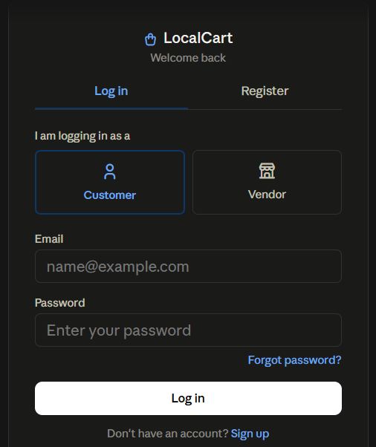

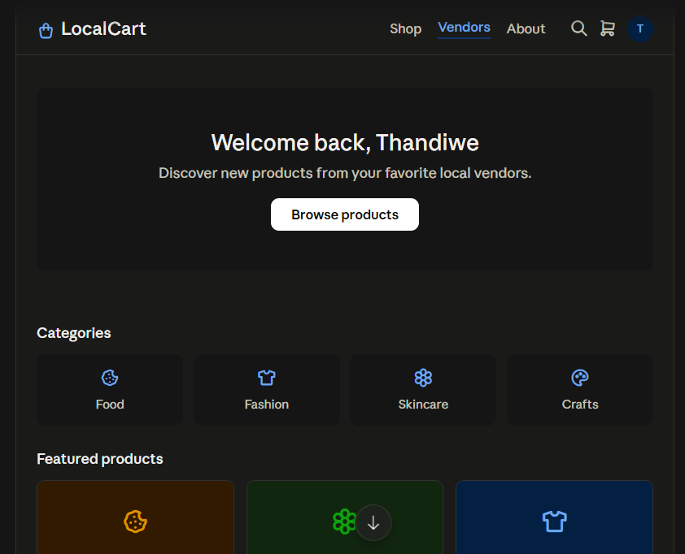
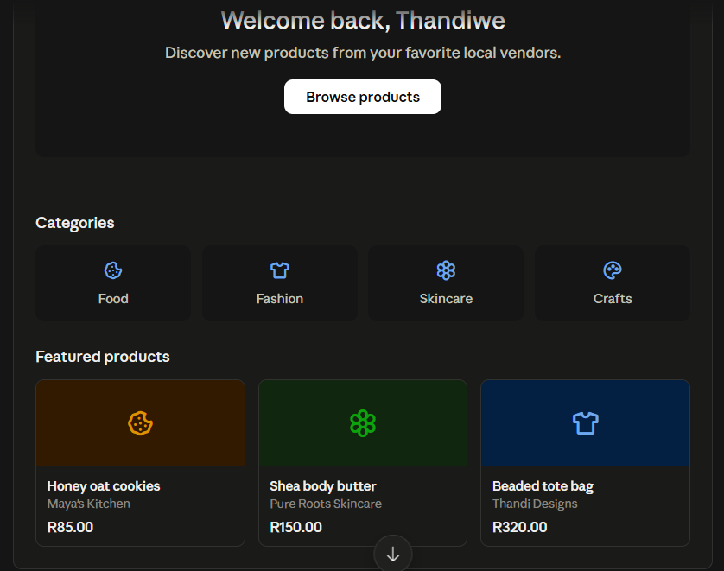

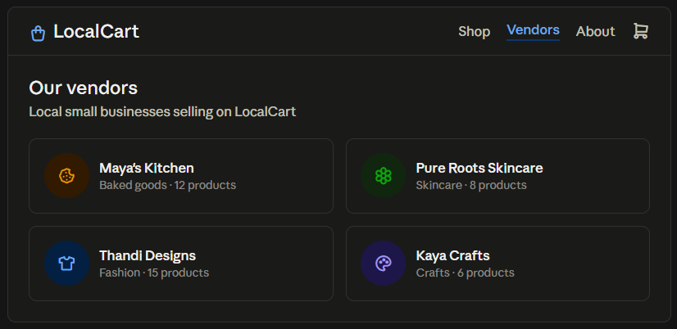

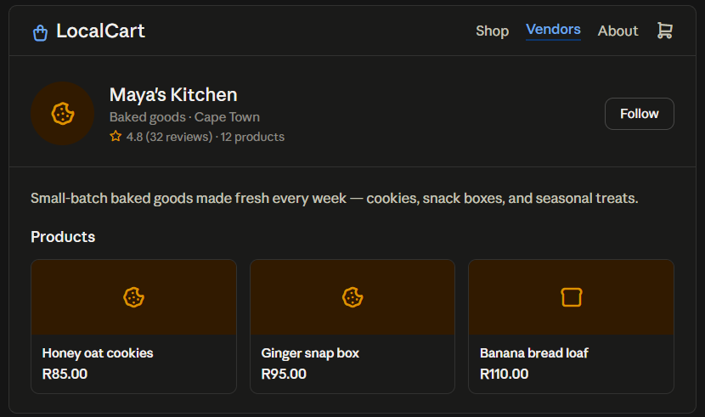

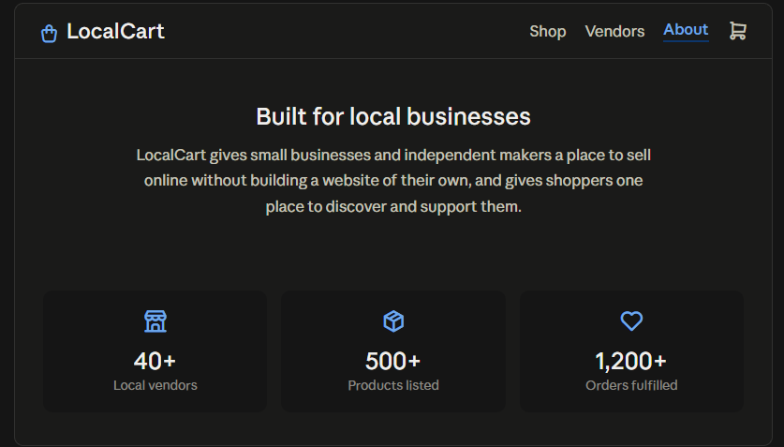

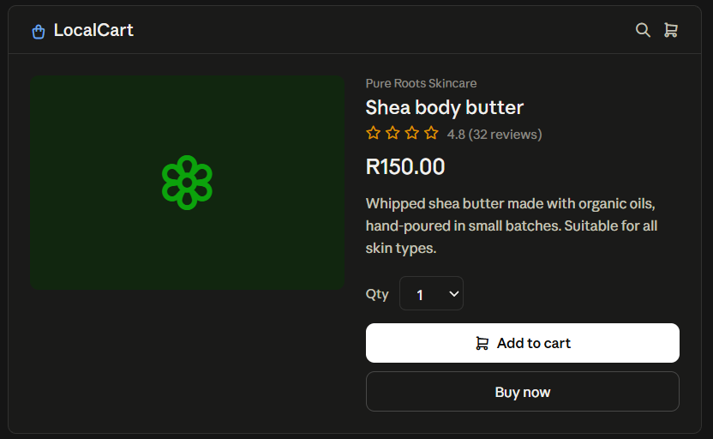

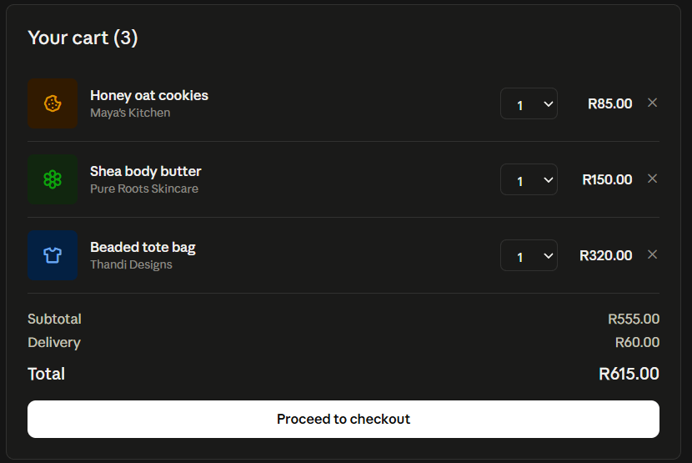

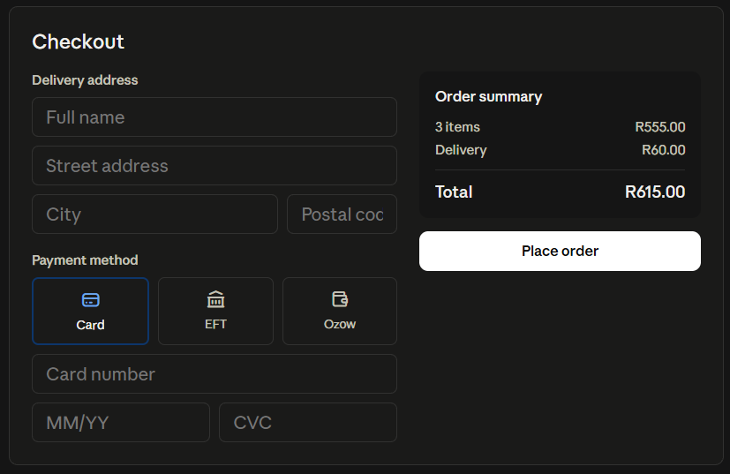

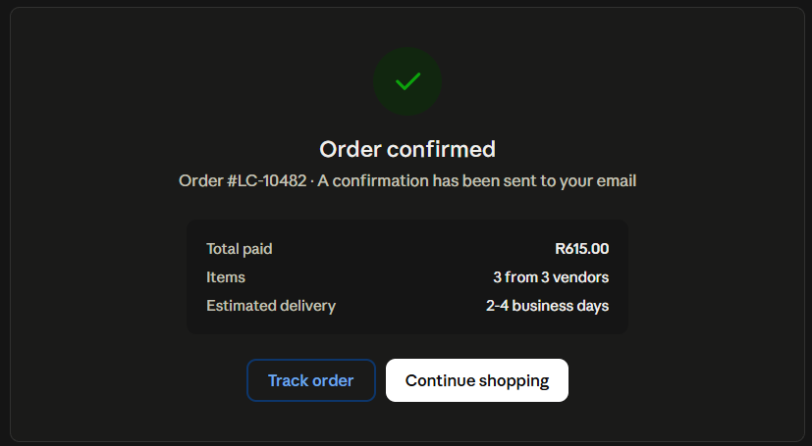

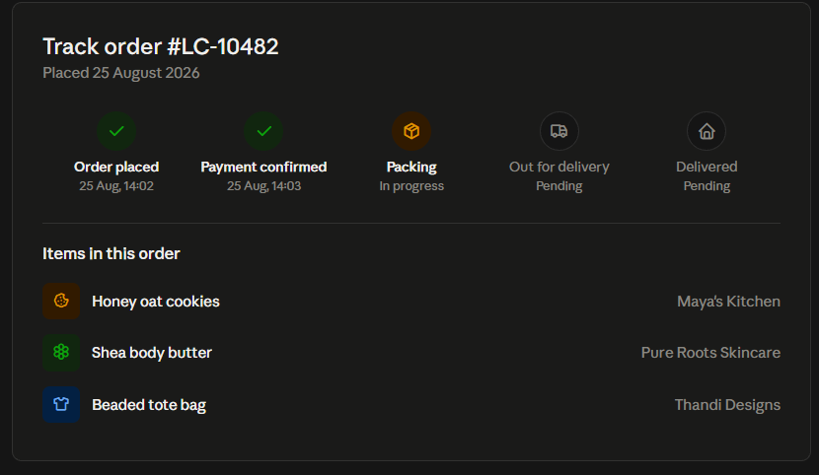

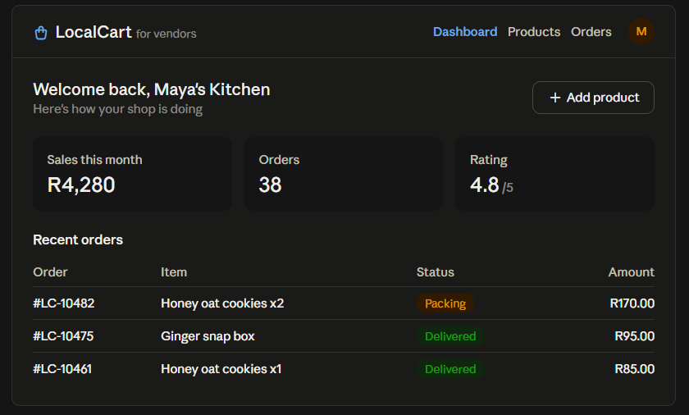

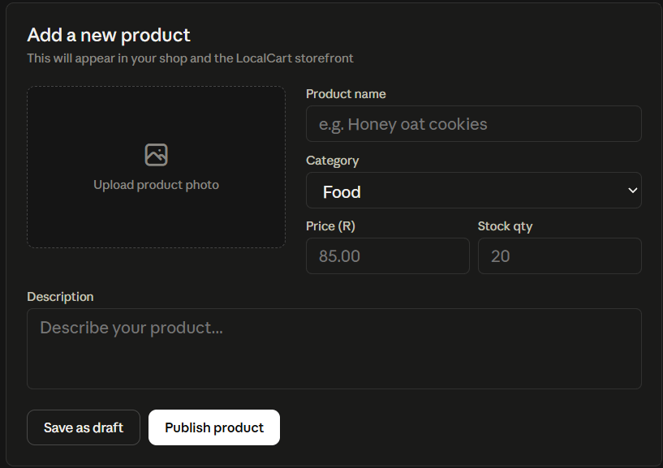

FOLDER STRUCTURE

frontend/
├── index.html (homepage)
├── login.html
├── register.html
├── vendors.html (vendor directory)
├── vendor.html (single vendor storefront)
├── product.html (product detail)
├── cart.html
├── checkout.html
├── confirmation.html
├── vendor-dashboard.html
├── add-product.html
│
├── css/
│ └── style.css
│
├── js/
│ ├── cart.js
│ ├── checkout.js
│ ├── auth.js
│ └── vendor-dashboard.js
│
└── assets/
├── images/
└── icons/

<header>
<div class="logo">
<span class="logo-mark">
<svg width="18" height="18" viewBox="0 0 24 24" fill="none" stroke="currentColor" stroke-width="2" stroke-linecap="round" stroke-linejoin="round">
<path d="M6 2 3 6v14a2 2 0 0 0 2 2h14a2 2 0 0 0 2-2V6l-3-4Z"></path>
<path d="M3 6h18"></path>
<path d="M16 10a4 4 0 0 1-8 0"></path>
</svg>
</span>
LocalCart
</div>

<nav>
<a href="#" class="active">Dashboard</a>
<a href="#">Vendors</a>
<a href="#">About</a>
<a href="#">Subscribe</a>
</nav>

<div class="header-right">
<button class="icon-btn" id="theme-toggle" aria-label="Toggle light and dark mode">
<svg class="icon-sun" width="17" height="17" viewBox="0 0 24 24" fill="none" stroke="currentColor" stroke-width="2" stroke-linecap="round" stroke-linejoin="round">
<circle cx="12" cy="12" r="4"></circle>
<path d="M12 2v2M12 20v2M4.93 4.93l1.41 1.41M17.66 17.66l1.41 1.41M2 12h2M20 12h2M4.93 19.07l1.41-1.41M17.66 6.34l1.41-1.41"></path>
</svg>
<svg class="icon-moon" width="17" height="17" viewBox="0 0 24 24" fill="none" stroke="currentColor" stroke-width="2" stroke-linecap="round" stroke-linejoin="round">
<path d="M21 12.79A9 9 0 1 1 11.21 3 7 7 0 0 0 21 12.79Z"></path>
</svg>
</button>

<label class="search-box">
<svg width="15" height="15" viewBox="0 0 24 24" fill="none" stroke="currentColor" stroke-width="2" stroke-linecap="round" stroke-linejoin="round"><circle cx="11" cy="11" r="8"></circle><line x1="21" y1="21" x2="16.65" y2="16.65"></line></svg>
<input type="text" placeholder="Search…" aria-label="Search products" />
</label>

<button class="icon-btn" aria-label="Cart" onclick="window.location.href='cart.html'">
<svg width="18" height="18" viewBox="0 0 24 24" fill="none" stroke="currentColor" stroke-width="2">
<circle cx="9" cy="21" r="1"></circle>
<circle cx="20" cy="21" r="1"></circle>
<path d="M1 1h4l2.68 13.39a2 2 0 0 0 2 1.61h9.72a2 2 0 0 0 2-1.61L23 6H6"></path>
</svg>
</button>

<div class="avatar">TM</div>
</div>
</header>

NAV BAR STYLING

:root, [data-theme="dark"]{
--bg: #141416;
--card: #1e1e22;
--card-hover: #26262b;
--border: #2c2c31;
--text: #f5f5f4;
--text-muted: #9b9ba3;
--text-faint: #6f6f78;
--accent: #f0811f;
--accent-hover: #ff9433;
--accent-ink: #17110a;
--shadow: rgba(0,0,0,0.35);
}

[data-theme="light"]{
--bg: #fbfaf8;
--card: #ffffff;
--card-hover: #f3f2ef;
--border: #e6e3dd;
--text: #17161a;
--text-muted: #5c5a63;
--text-faint: #8f8d95;
--accent: #e8760f;
--accent-hover: #d3690a;
--accent-ink: #ffffff;
--shadow: rgba(20,20,22,0.08);
}

/* ---------- Header ---------- */
header{
display:flex;
align-items:center;
justify-content:space-between;
padding: 18px 40px;
border-bottom: 1px solid var(--border);
gap: 24px;
}

.logo{
display:flex;
align-items:center;
gap:10px;
font-weight: 700;
font-size: 19px;
letter-spacing: -0.01em;
flex-shrink:0;
}

.logo-mark{
width: 32px;
height: 32px;
border-radius: 8px;
background: var(--accent-soft, rgba(106,92,255,0.14));
display:flex;
align-items:center;
justify-content:center;
color: #6a5cff;
flex-shrink:0;
}

nav{
display:flex;
align-items:center;
gap: 32px;
font-size: 14.5px;
font-weight: 500;
}

nav a{
color: var(--text-muted);
position: relative;
padding-bottom: 4px;
transition: color .15s ease;
}
nav a:hover{ color: var(--text); }
nav a.active{ color: var(--accent); }
nav a.active::after{
content:"";
position:absolute;
left:0; right:0; bottom:-14px;
height:2px;
background: var(--accent);
}

.header-right{
display:flex;
align-items:center;
gap: 14px;
}

.search-box{
display:flex;
align-items:center;
gap: 8px;
background: var(--card);
border: 1px solid var(--border);
border-radius: 999px;
padding: 9px 16px;
color: var(--text-faint);
font-size: 13.5px;
min-width: 200px;
transition: border-color .15s ease;
}
.search-box:focus-within{ border-color: var(--accent); }
.search-box input{
background: none;
border: none;
outline: none;
color: var(--text);
font-size: 13.5px;
width: 100%;
font-family: inherit;
}
.search-box input::placeholder{ color: var(--text-faint); }

.icon-btn{
background: var(--card);
border: 1px solid var(--border);
color: var(--text);
cursor:pointer;
display:flex;
align-items:center;
justify-content:center;
width: 36px;
height: 36px;
padding:0;
border-radius: 50%;
flex-shrink:0;
transition: background .15s ease, border-color .15s ease, transform .15s ease;
}
.icon-btn:hover{ background: var(--card-hover); border-color: #3a3a41; }
.icon-btn:active{ transform: scale(0.94); }

#theme-toggle .icon-moon{ display: none; }
[data-theme="light"] #theme-toggle .icon-sun{ display: none; }
[data-theme="light"] #theme-toggle .icon-moon{ display: block; }

.avatar{
width: 34px;
height: 34px;
border-radius: 50%;
background: linear-gradient(135deg, #6a5cff, #b23fd8);
display:flex;
align-items:center;
justify-content:center;
font-size: 13px;
font-weight: 700;
color: #fff;
flex-shrink:0;
border: 2px solid var(--border);
}

Footer
<footer class="site-footer">
<div class="footer-logo">
<span class="logo-mark">
<svg width="16" height="16" viewBox="0 0 24 24" fill="none" stroke="currentColor" stroke-width="2" stroke-linecap="round" stroke-linejoin="round">
<path d="M6 2 3 6v14a2 2 0 0 0 2 2h14a2 2 0 0 0 2-2V6l-3-4Z"></path>
<path d="M3 6h18"></path>
<path d="M16 10a4 4 0 0 1-8 0"></path>
</svg>
</span>
LocalCart
</div>

<nav class="footer-links">
<a href="#">Shop</a>
<a href="#">Vendors</a>
<a href="#">About</a>
<a href="#">Contact</a>
</nav>

<p class="footer-copy">© 2026 LocalCart. Supporting small South African businesses.</p>
</footer>

Footer styling

/* ---------- Footer ---------- */
.site-footer{
display:flex;
flex-direction:column;
align-items:center;
text-align:center;
gap: 18px;
padding: 48px 24px 40px;
border-top: 1px solid var(--border);
}
.footer-logo{
display:flex;
align-items:center;
gap: 9px;
font-weight: 700;
font-size: 16px;
}
.footer-logo .logo-mark{
width: 28px;
height: 28px;
}
.footer-links{
display:flex;
flex-wrap: wrap;
justify-content:center;
gap: 28px;
font-size: 13.5px;
font-weight: 500;
}
.footer-links a{
color: var(--text-muted);
transition: color .15s ease;
}
.footer-links a:hover{ color: var(--text); }

.footer-social{
display:flex;
gap: 12px;
}
.social-btn{
width: 36px;
height: 36px;
border-radius: 50%;
background: var(--card);
border: 1px solid var(--border);
display:flex;
align-items:center;
justify-content:center;
color: var(--text-muted);
transition: background .15s ease, border-color .15s ease, color .15s ease, transform .15s ease;
}
.social-btn:hover{
background: var(--card-hover);
border-color: var(--accent);
color: var(--accent);
transform: translateY(-2px);
}

.footer-copy{
font-size: 12.5px;
color: var(--text-faint);
margin: 6px 0 0;
}

